https://www.w3schools.com/bootstrap/bootstrap_ref_comp_glyphs.asp

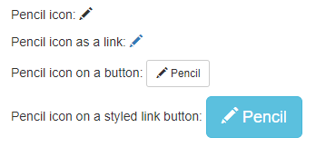

<div class="container">

<p>Pencil icon: <span class="glyphicon glyphicon-pencil"></span></p>

<p>Pencil icon as a link:

<a href="#">

<span class="glyphicon glyphicon-pencil"></span>

</a>

</p>

<p>Pencil icon on a button:

<button type="button" class="btn btn-default btn-sm">

<span class="glyphicon glyphicon-pencil"></span> Pencil

</button>

</p>

<p>Pencil icon on a styled link button:

<a href="#" class="btn btn-info btn-lg">

<span class="glyphicon glyphicon-pencil"></span> Pencil

</a>

</p>

</div>

|  |  |  |
| --- | --- | --- |
|  |  |  |
|  |  |  |